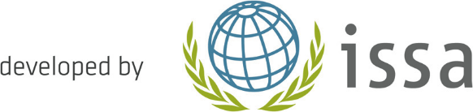
Golden Rule 2:
Identify hazards–
Control risks
Risk assessment serves as the essential tool for the timely and systematic identification of hazards and risks and to implement preventive actions. Accidents, injuries and near misses should also be
evaluated.
Goals -  What do I want to achieve? | Implementation -  How do I proceed? | Support-  Who do I need to participate? | Deadline -  By when?
 |  |  | Short term:
 |  |  | In the medium term:
 |  |  | In the long run:

